Handout no. 5

|  |  |
| --- | --- |
| **Name** | Faizan Azam, Muhammad Asad, AsadurRehman |
| **Reg. No** | 2019-EE-381, 383, 389 |
| **Marks/Grade** |  |

**EXPERIMENT # 5**

**Three Phase Voltage transformers**

**Objective:**

At the end of this lab session students will be able to

* Use De Lorenzo power system Protection kits.
* Implement “Three Voltage transformer” by using De Lorenzo power system Protection kits.
* Assembling the common voltage transformer circuit for measurement in three phase network.
* Measuring the residual voltage in a three phase system with the fault to ground.

**Introduction:**

Utilities are responsible for the generation, transmission and distribution of electricity to customers. Part of this responsibility is ensuring a safe but yet reliable power supply to customers. For the purpose of safety and protecting the transmission and distribution network from faults, utilities worldwide have sophisticated protective equipment. Collectively, these are known as secondary equipment and include the current transformers (CT), potential transformer (PT) and protective relays.

**Apparatus:**

* 1DL 1013T1 Three Phase Power Supply
* 1DL 2109T24 Three Phase Voltage Transformer
* 2 DL 2109T3PV Moving iron voltmeter (125-250-500 V)

**Voltage Transformers:**

Potential transformers are parallel connected and are designed to read the voltage phase and ratio relationship during metering. One can connect the primary terminals on a potential transformer in two configurations. These configurations include line to line, or line to neutral.

There are three different types of potential transformers, including an electromagnetic type, a capacitor, and an optical. The optical potential transformer s used in conjunction with electrical properties of optical equipment. The capacitor type is used for higher voltages, and the electromagnetic potential transformer is of the wire-round type. In potential transformers, burden and accuracy are combined, as they are dependent on each other. Most potential transformers have smaller cores and capacities when compared to power transformers.

When using a potential transformer, certain quantities need to be scaled prior to use. These include power, voltage, demand and energy. The use of transformers and potential transformers will require some basic electrical wiring knowledge, as well as experience with voltage.

**Circuit Diagram:**

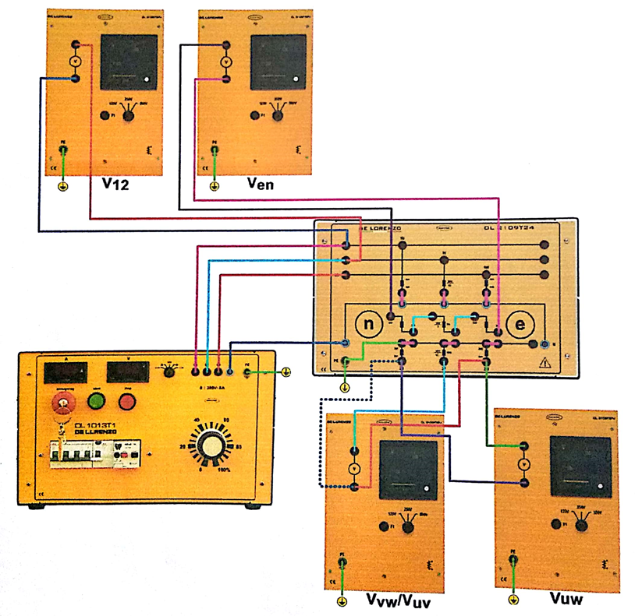

**Fig: 01 (Normal Operation)**

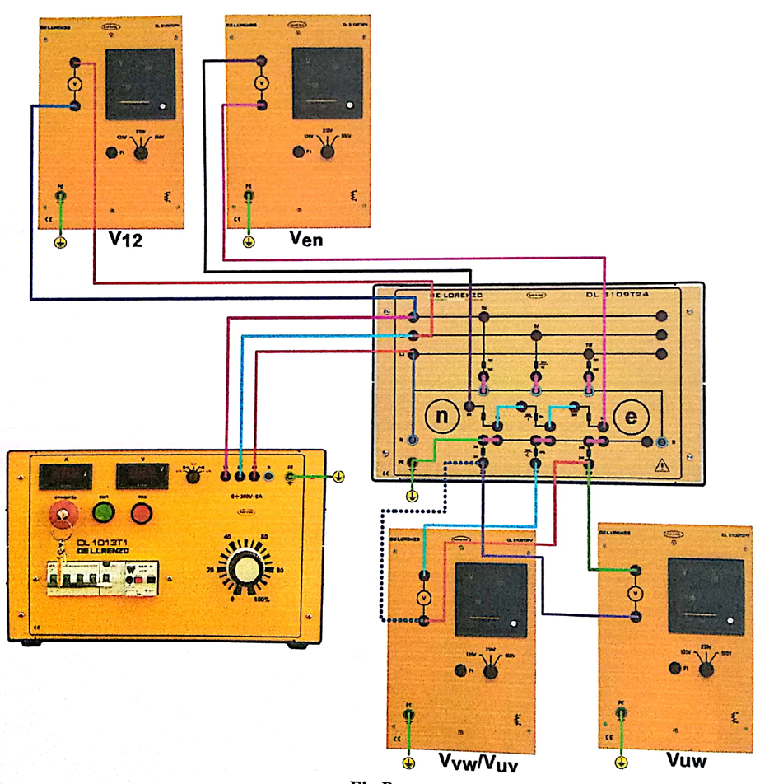

**Fig: 02 (Faults to ground)**

**Procedure:**

Assemble the circuit according to the foregoing topographic diagram. Initially don’t use the connection to simulate a fault to ground.

Don’t forget that the voltage transformer should not be short circuited on the secondary side !

The three-phase voltage transformer is connected as three single pole isolated transformers: the secondary side in the star connection supplies an image of the three phase voltages of the network while the auxiliary windings are in series and serves to measure the fault to the ground.

Set the supply voltage to UL12=250 V and measure the voltage of the secondary winding:

U12 = 65 V U23 = 65 V U13 = 65 V

And the voltages between terminals “n” and “e” of the individual auxiliary windings connected in series:

**Ucn = 1.1 V**

In the symmetrical load operation, the residual voltage Ucn = 0V and the voltage transformer responds as expected according to the transformation ratio.

Now in order to simulate the fault to ground in a network with isolated neutral point, remove the connection to the neutral conductor at the output side of the three-phase power supply and connect the phase L3 to star point N of the primary winding, see fig. B( see detailed diagram to simulate a fault to the ground).

In this experiment, great care must be taken to ensure that the neutral conductor of the three-phase voltage transformer doesn’t remain connected with the neutral of three phase power supply, as otherwise, a short circuit to ground would occur, which would cause an overload.

Set again the power supply voltage to UL12=250 V and measure the voltages at the terminal “n” and “e” of the three individual auxiliary windings connected in series.

**Ucn = 66.5 V**

And interpret this measurement result with the help of following phasor diagram.

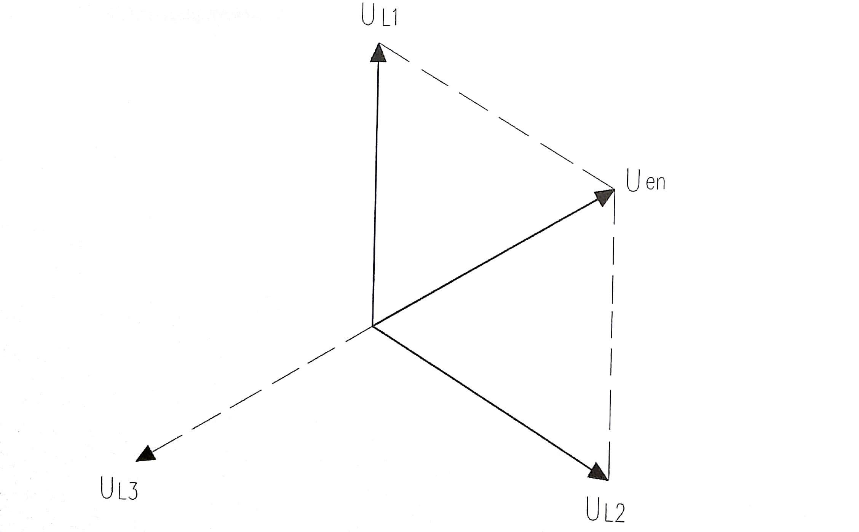

**Fig: 03 (Phasor Diagram)**

* **Diagram:**
* **With line to Neutral:**

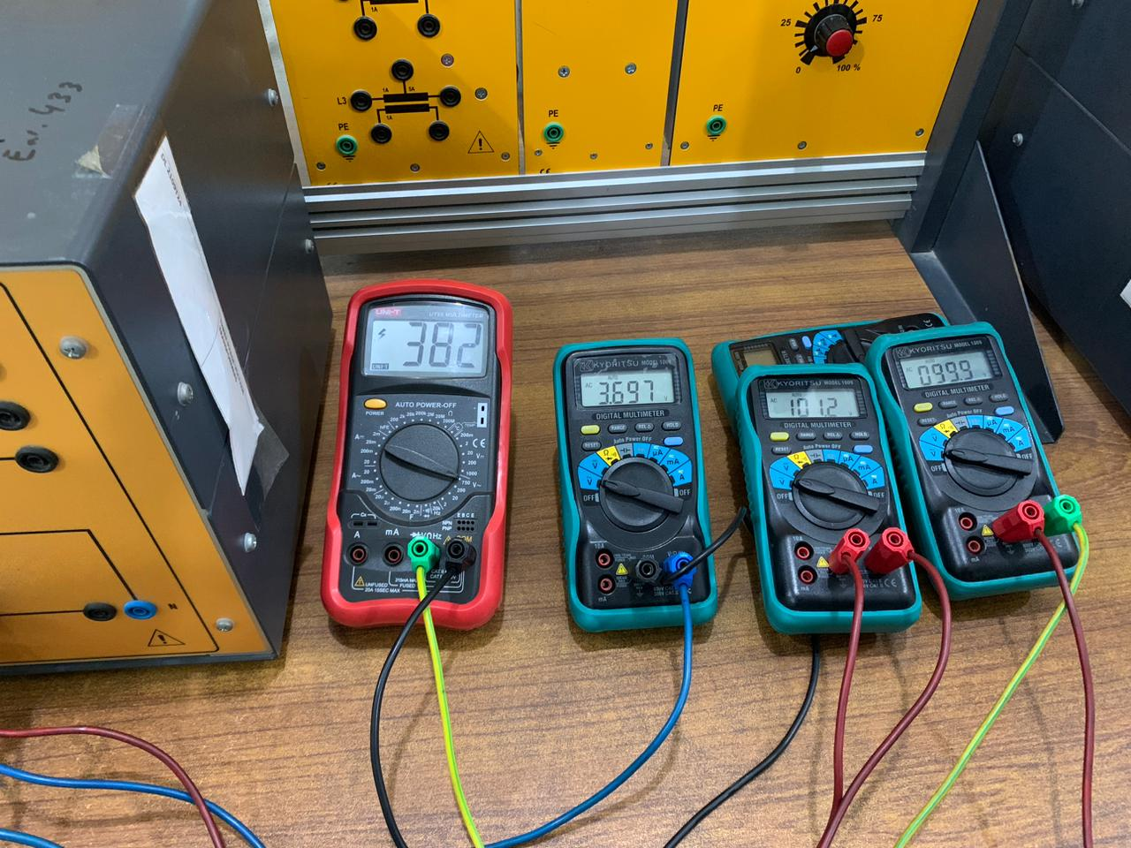

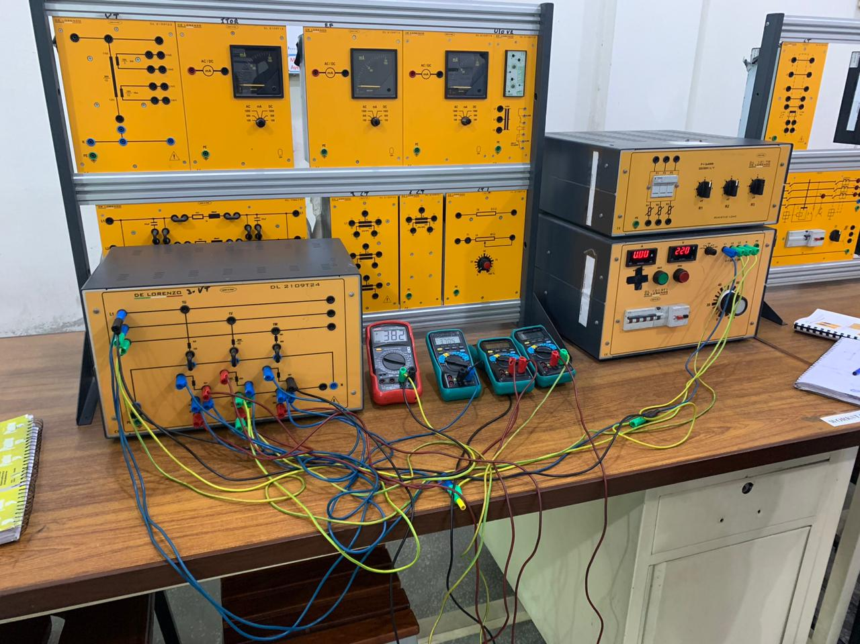

* 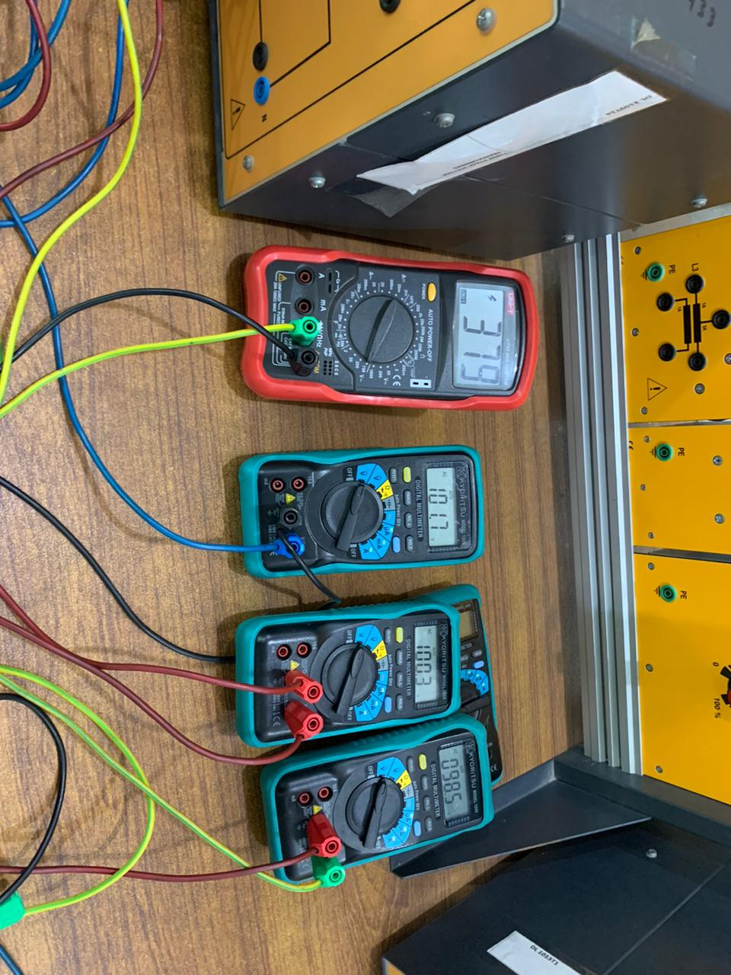**With line to line:**

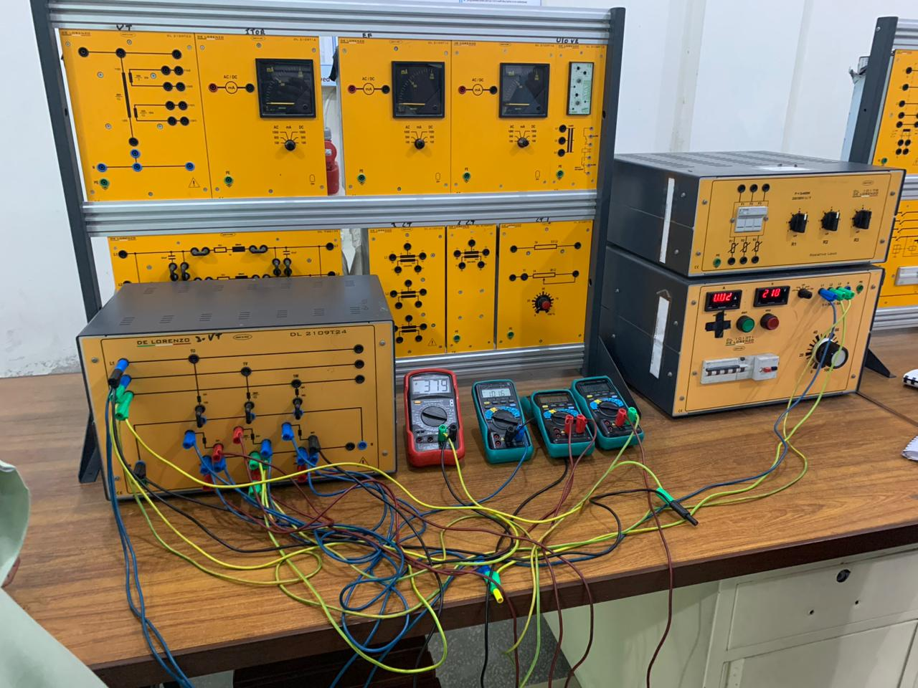

**Observation:**

In this I learnt how to connect three phase voltage transformer through its wiring diagram. I measured the primary, auxiliary and secondary voltages in normal condition and faulty condition. I saw that during the normal operation there was very small voltages (1.1 V) due to ac voltages (stary) which is supposed to be negligible. During line to ground fault there is huge amount of voltages appeared across the auxiliary winding which give the indication of fault.